

Course Embedded Systems Design
Student Name Huang Yanlin
Student Number 192050222
Date 2020.07.9
Lab 3

Description of task
1.Create a new project
2. Create two task
3. Create one queue
4. One of the tasks flashes briefly LED when receiving information from the queue.
5. The second task writes any number to the queue and delayed 1 sec.

Description how to do the task
- Create new STM32 project and Select MCU,name it prj3
- About MCU:select STM32F29ZI
- Then,we are waiting for files to be uploaded for the selected microcontroller from the manufacturer's website.
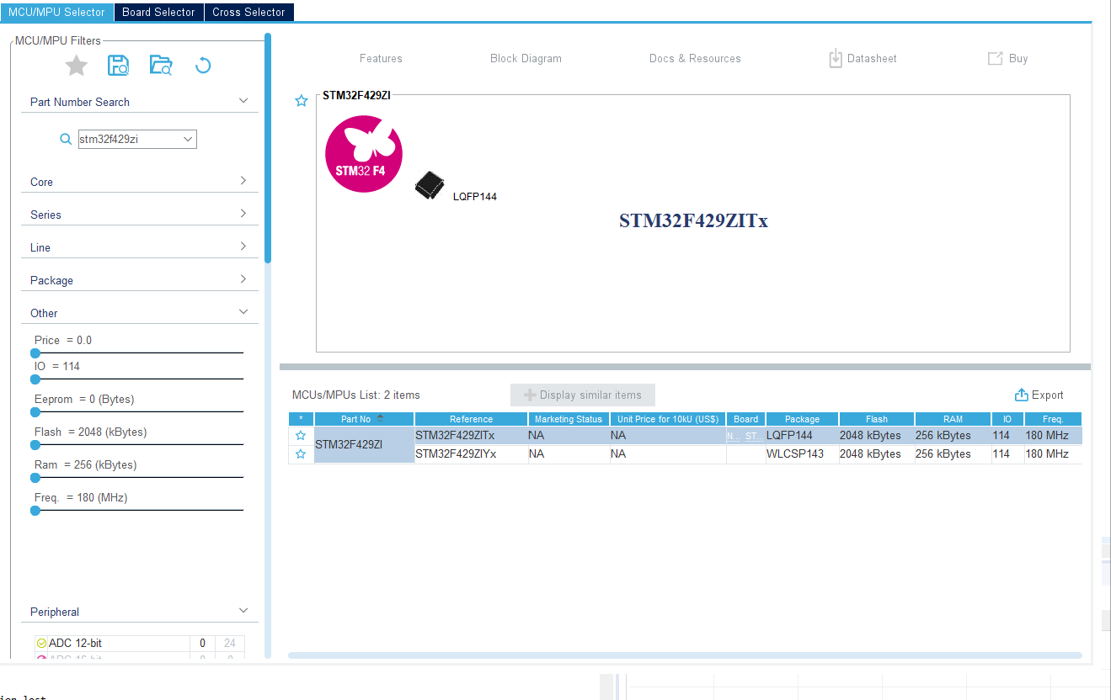

After files to be uploaded
- User LD2:a blue user LED is connected to PB7. Switch it to the output.
- User LD3:a red user LED is connected to PB14. Switch it to the output.

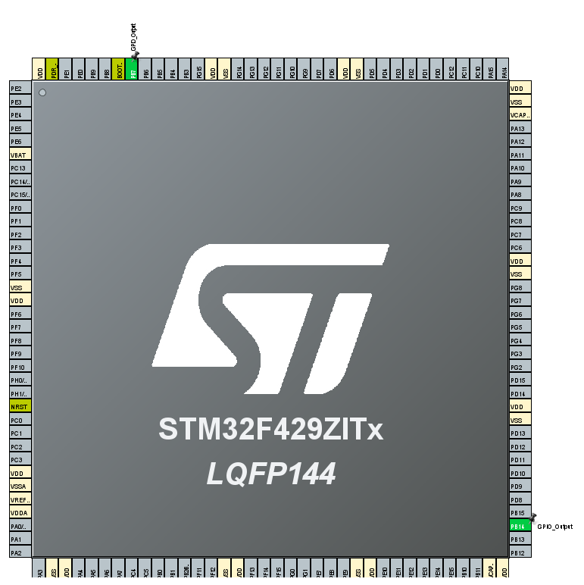

- Select Middleware,chose FREEROTS,and about interface,chose CMSIS_V2
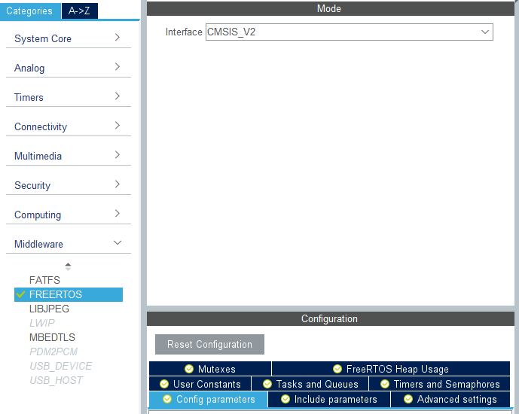
4.In Lab2.ioc,in Middleware->FREERTOS,about Tasks and Queues,I add Tasks.Just like this:
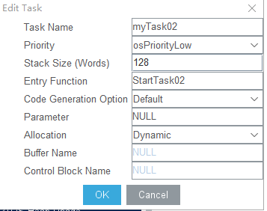

5.Click the Save button and generate the code.

Code
- Insert the header file：#include "queue.h" in main.c
- Define queue： xQueueHandle q;
- Create a queue in main function ： q = xQueueCreate(8, sizeof(unsigned int));
- Use xQueueSend to send data

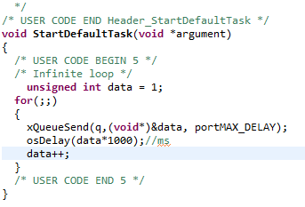
- Use xQueueReceive to receive data
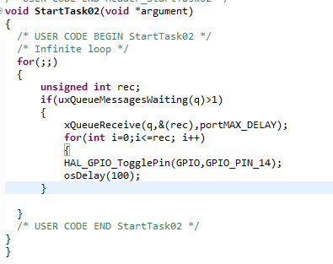
6.Press Run prj3 Debug, we can LD3 lights red

